**Project 3 (SEM / SMM)**

**E-commerce (Makeup products)**

**Search Engine Marketing Project**

1. **Keyword Research using Keyword Planner with Average Bid Value**

| **Keyword** | **Avg. monthly searches** | **Competition** | **Top of page bid (low range)** | **Top of page bid (high range)** |
| --- | --- | --- | --- | --- |
| lipstick | 500000 | High | 2.45 | 36.32 |
| foundation | 500000 | Low | 2.91 | 23.22 |
| eyeshadow | 50000 | High | 1.72 | 18.47 |
| mac lipstick | 50000 | High | 2.18 | 22.63 |
| dior lipstick | 50000 | High | 1.20 | 14.25 |
| maybelline lipstick | 50000 | High | 2.27 | 48.64 |
| revlon lipstick | 50000 | High | 1.20 | 12.41 |
| bobbi brown lipstick | 50000 | High | 1.41 | 20.27 |
| lakme lipstick | 50000 | High | 0.98 | 10.22 |
| huda beauty lipstick | 50000 | High | 1.46 | 16.44 |
| sephora lipstick | 50000 | High | 1.44 | 42.55 |
| huda beauty eyeshadow palette | 50000 | High | 3.20 | 22.93 |
| colorbar lipstick | 50000 | High | 1.17 | 16.12 |
| lakme 9 to 5 lipstick | 50000 | High | 1.14 | 12.22 |
| elle 18 lipstick | 50000 | High | 1.04 | 4.21 |
| nude romance | 50000 | Low |  |  |
| maybelline superstay | 5000 | High | 2.01 | 24.53 |
| nars lipstick | 5000 | High | 1.87 | 15.81 |
| charlotte tilbury lipstick | 5000 | High | 1.21 | 13.82 |
| pillow talk lipstick | 5000 | High | 1.00 | 17.12 |
| maybelline superstay matte ink | 5000 | High | 2.42 | 47.22 |
| kylie lip kit | 5000 | High | 1.93 | 34.59 |
| mac eyeshadow | 5000 | High | 3.98 | 25.18 |
| gucci lipstick | 5000 | High | 8.73 | 45.08 |
| mac velvet teddy | 5000 | High | 2.67 | 12.92 |
| mac lip liner | 5000 | High | 2.26 | 13.66 |
| estee lauder lipstick | 5000 | High | 2.35 | 17.37 |
| charlotte tilbury pillow talk lipstick | 5000 | High | 1.30 | 16.49 |
| nyx lipstick | 5000 | High | 1.14 | 13.44 |

1. **Implement Keyword Match types**

#### **Exact Match:**

**Keywords**:

* [“best liquid foundation”]
* [“buy eyeshadow online”]
* [“organic lip balm”]

#### **Phrase Match:**

**Keywords**:

* "matte lipstick"
* "long-lasting foundation"
* "best mascara for volume"
* "vegan makeup brands"

#### **Broad Match:**

**Keywords**:

* cruelty-free makeup
* cheap makeup brushes

1. **Design Landing Page Wireframe**

<https://wireframe.cc/NmSPNo>

1. **Google Ad Simulation**

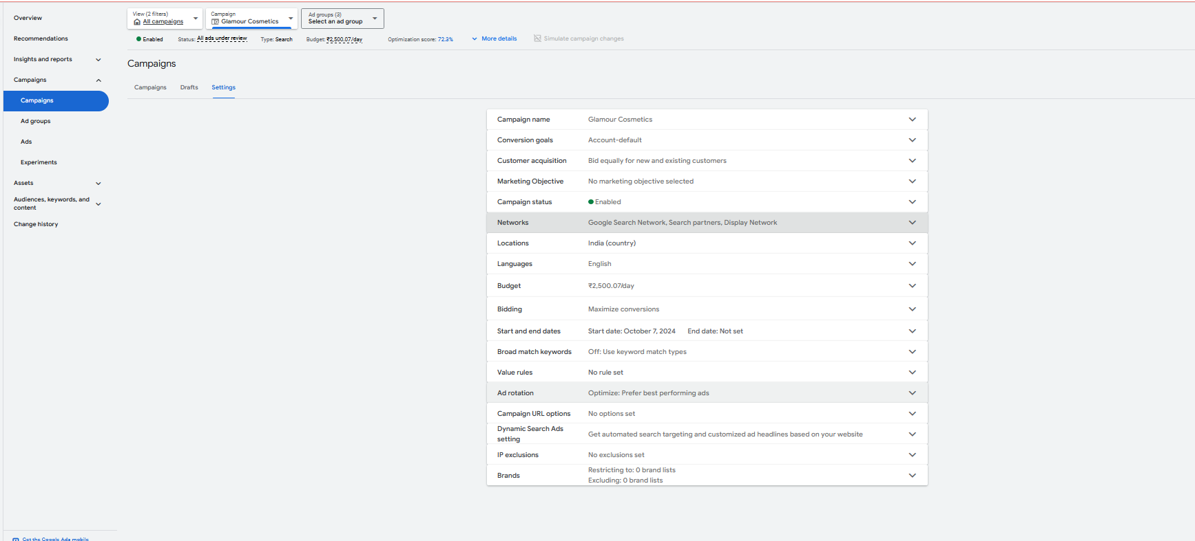

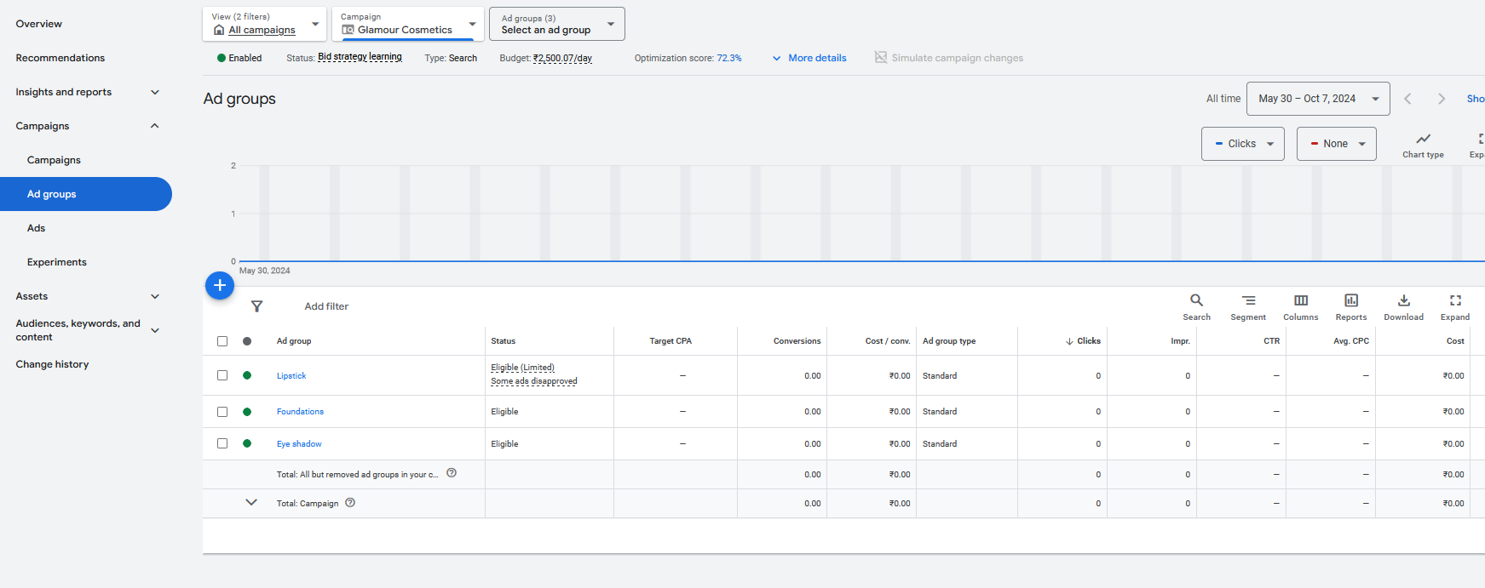

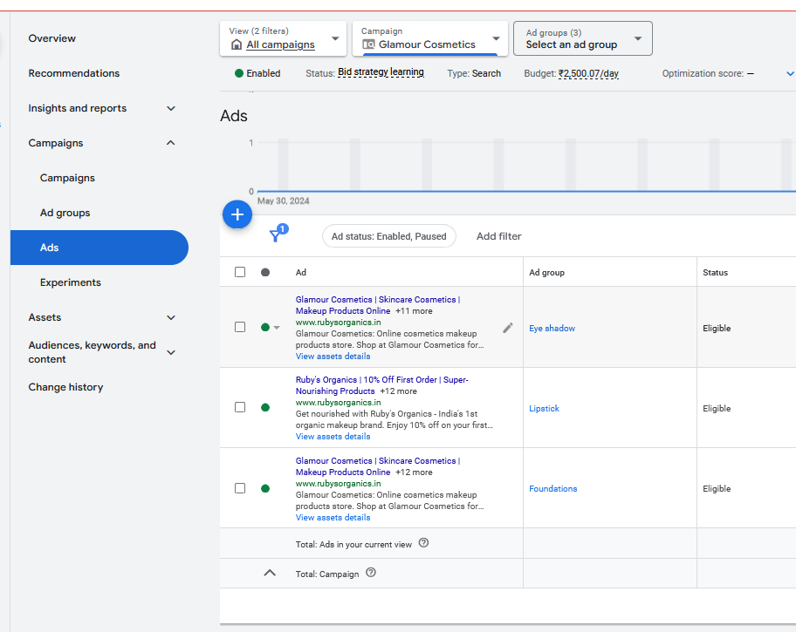

**Social Media Marketing Project**

1. **Competitor Analysis**

#### **Company 1: Sephora**

#### **Company 2: Nyka**

### **1. Product Range**

* **Sephora**:
  + **Diversity**: Offers a wide range of makeup products from high-end luxury brands to mid-tier cosmetics. It features both premium international brands like Fenty Beauty, Huda Beauty, NARS, and Dior as well as emerging niche brands.
  + **Exclusive Products**: Sephora offers exclusive products and collaborations that cannot be found in other stores.
  + **Variety**: Categories include everything from foundations, lipsticks, eyeshadows, skincare, haircare, and fragrance.
* **Nykaa**:
  + **Diversity**: Offers both international and Indian brands but focuses on a broader consumer base by including affordable options, catering to mass markets.
  + **Nykaa Private Label**: Apart from hosting international and domestic brands, Nykaa also has its own product lines (e.g., Nykaa Cosmetics, Nykaa Naturals), which are popular for their affordability and quality.
  + **Variety**: Similar to Sephora, Nykaa has a comprehensive range of makeup, skincare, and beauty tools. However, Nykaa leans slightly towards affordability, including products for budget-conscious customers.

**Key Difference**: Sephora leans towards a luxury market, focusing on exclusive and high-end products, whereas Nykaa balances affordability and premium, catering to a wider audience with its own product lines and more budget-friendly options.

### **2. Pricing Strategy**

* **Sephora**:
  + **High-End Pricing**: Sephora is positioned as a premium beauty retailer, with its pricing reflecting the high-end brands it carries.
  + **Discounts and Offers**: Sephora offers loyalty programs (like Beauty Insider), occasional discounts, and special member rewards, but deep discounts are rare compared to lower-cost beauty stores.
* **Nykaa**:
  + **Affordable to Premium Range**: Nykaa covers a broader range of pricing, from affordable drugstore brands to high-end luxury products. It’s positioned to appeal to both value-conscious and premium customers.
  + **Frequent Sales**: Nykaa frequently hosts seasonal and festive sales (e.g., Nykaa Pink Friday Sale, End of Season Sale) with significant discounts across categories. Offers and discounts are a key part of Nykaa’s pricing strategy.

**Key Difference**: Sephora focuses on premium pricing with exclusive high-end products, whereas Nykaa is known for offering both affordable options and frequent discounts, making it more accessible to a broader customer base.

### **3. Website Usability & Design**

* **Sephora**:
  + **Design**: Sephora’s website is visually rich, focusing on luxury aesthetics with high-quality product images, videos, and editorial content.
  + **User Experience**: The site is easy to navigate with intuitive product filters (by category, brand, shade, etc.) and personalized recommendations based on previous purchases.
  + **Mobile Experience**: Sephora's mobile app and website are well-optimized for users, offering seamless integration of e-commerce and product discovery features.
* **Nykaa**:
  + **Design**: Nykaa’s website is functional, with a clean design and easy-to-use interface. It’s not as luxurious or editorial-focused as Sephora, but highly efficient for browsing.
  + **User Experience**: The site offers multiple filters (price, brand, type), and it's very user-friendly with a focus on ease of shopping and finding deals. Nykaa also includes user-generated content such as customer reviews and ratings.
  + **Mobile Experience**: Nykaa has a highly optimized mobile app that performs well for shopping, featuring app-only discounts and notifications for sales.

**Key Difference**: While both websites are user-friendly, Sephora's design emphasizes luxury and aesthetics, whereas Nykaa focuses on functionality and ease of shopping with a slightly more straightforward interface.

### 

### **4. Marketing & SEO Strategy**

* **Sephora**:
  + **Content Marketing**: Sephora uses rich content, including beauty tutorials, product recommendations, and how-to guides. They have a strong presence on YouTube, Instagram, and other social platforms.
  + **Influencer Collaborations**: Sephora collaborates with top-tier beauty influencers and celebrities to market their products.
  + **SEO**: Sephora invests heavily in SEO for high-intent keywords like “best foundation for oily skin” or “luxury makeup,” targeting shoppers looking for premium products.
  + **Email Marketing**: Personalized email campaigns with new product launches and exclusive offers for loyalty members are frequent.
* **Nykaa**:
  + **Content Marketing**: Nykaa has a robust content marketing strategy through its **Nykaa Beauty Book** (blog), YouTube tutorials, and influencer collaborations. They focus on both high-end and mass-market products.
  + **SEO**: Nykaa targets a wider range of keywords, both for budget and premium segments. They dominate Indian beauty-related searches with keywords like “affordable makeup in India” and “best skincare products in India.”
  + **Influencer Marketing**: Nykaa partners with a mix of Indian beauty influencers, including micro-influencers, to tap into various audience segments.
  + **Social Media**: Nykaa actively uses Instagram, YouTube, and Facebook for live tutorials, product reviews, and engagement. They also promote app-only discounts and use push notifications effectively.

**Key Difference**: Sephora focuses more on luxury and premium branding in its marketing, leveraging top-tier influencers, while Nykaa adopts a broader strategy with a mix of influencer types and more aggressive SEO for various budget segments.

### **5. Customer Engagement & Loyalty Programs**

* **Sephora**:
  + **Loyalty Program**: Sephora’s **Beauty Insider** program is one of the most popular loyalty programs. It offers tiered membership (Insider, VIB, and Rouge) based on spending, with higher tiers receiving exclusive rewards and early access to products.
  + **In-Store & Online**: Sephora integrates both in-store and online experiences, allowing customers to collect points regardless of the channel they use to shop.
* **Nykaa**:
  + **Loyalty Program**: Nykaa has its own loyalty program called **Nykaa Rewards**, which offers points for every purchase that can be redeemed for discounts on future purchases. However, it is less tiered and exclusive than Sephora’s system.
  + **Online-Only Focus**: Nykaa’s customer engagement is primarily focused online, but it has started expanding offline as well with Nykaa Luxe and On Trend stores.

**Key Difference**: Sephora’s loyalty program is more established, tiered, and offers premium perks, while Nykaa has a more straightforward rewards system catering to all types of buyers, focusing on easy online shopping.

### **6. Customer Service & Returns**

* **Sephora**:
  + **Customer Support**: Sephora offers high-quality customer service, including live chat, in-store support, and detailed FAQs for both online and offline purchases.
  + **Return Policy**: Sephora has a flexible return policy that allows for returns within 60 days, both online and in-store, which adds value for high-end consumers.
* **Nykaa**:
  + **Customer Support**: Nykaa’s customer support is primarily online through email, chat, and phone, with a focus on assisting with orders, returns, and account management.
  + **Return Policy**: Nykaa offers a 15-day return policy, which is shorter compared to Sephora, and is more focused on unopened or defective products.

**Key Difference**: Sephora’s customer service and return policies are more flexible and accommodating, particularly for high-end purchases, while Nykaa has a more standard and time-limited return policy.

### **Summary:**

| **Criteria** | **Sephora** | **Nykaa** |
| --- | --- | --- |
| **Product Range** | High-end, exclusive luxury brands | Wide range, from budget to premium |
| **Pricing** | Premium pricing with loyalty benefits | Affordable to premium, frequent sales |
| **Website Design** | Luxury, visually rich | Clean, functional, deals-focused |
| **Marketing** | High-end influencer marketing, premium SEO | Broad SEO, influencer tiers, mass-market |
| **Customer Engagement** | Tiered loyalty program, multi-channel | Simple rewards, strong online focus |
| **Customer Service** | Excellent support, flexible return policy | Standard online support, shorter returns |

**Conclusion**: Sephora targets a more niche, high-end market with luxury products and premium customer service, while Nykaa appeals to a wider audience by balancing affordable and premium products, leveraging frequent discounts, and focusing on both local and international brands.

1. **Target Audience Research for Paid Facebook and Instagram Ads**

### **1. Demographic Targeting**

#### **Age:**

* **Primary Age Range**: **18-35 years** old
  + The majority of makeup consumers fall into this age group, with younger audiences (18-25) being more experimental and active on social platforms.
* **Secondary Age Range**: **35-45 years** old
  + This group includes more financially stable customers looking for high-quality or luxury makeup products.

#### **Gender:**

* **Primarily Female** (85-90% of the target audience)
* Include **Males interested in beauty** (10-15%) – Many men are now interested in skincare, grooming, and even makeup products.

#### **Location:**

* **Urban Areas**: Target users in cities with a higher demand for makeup and beauty products. For example:
  + In India: Cities like **Mumbai, Delhi, Bangalore, Chennai, Kolkata, Hyderabad**.
  + Globally: Cities like **New York, Los Angeles, London, Paris, Tokyo**.
* **Tier 2 Cities**: For brands like Nykaa, targeting **Tier 2 cities** in India like Pune, Lucknow, Jaipur, and others helps reach emerging consumers in growing markets.

#### **Income Level:**

* **Middle-to-High Income**: Customers with disposable income who are willing to spend on beauty and skincare products.
* **Luxury/High Income**: For high-end makeup, targeting those with higher income, possibly professionals, influencers, and beauty enthusiasts.

### **2. Interest-Based Targeting**

**Makeup & Beauty Enthusiasts**:

* **Interests**: Beauty blogs, makeup tutorials, beauty YouTubers, and cosmetic brands.
* **Behavior**: People who actively engage with beauty content (e.g., liking posts from makeup brands, watching makeup tutorials).
* **Brands**: Target users who follow beauty brands like **Sephora, Nykaa, MAC, Huda Beauty, Kylie Cosmetics**, etc.

**Skincare Enthusiasts**:

* **Interests**: Skincare routines, organic skincare, anti-aging products, and cruelty-free cosmetics.
* **Behavior**: Followers of skincare influencers, blogs, and YouTube channels.
* **Brands**: Include users interested in brands like **The Ordinary, Clinique, Kiehl’s**, and other skincare-focused brands.

**Luxury Consumers**:

* **Interests**: High-end fashion, luxury skincare and beauty brands, premium services.
* **Brands**: Target users interested in **Chanel Beauty, Tom Ford, Dior**, and other luxury beauty brands.
* **Shopping Behavior**: Look for users who engage with high-end department stores and online luxury platforms.

**Eco-Conscious Consumers**:

* **Interests**: Sustainable beauty, cruelty-free products, vegan makeup, and organic skincare.
* **Behavior**: Users interested in eco-friendly products, follow brands and influencers that promote sustainability.
* **Brands**: Brands like **Lush, Tarte, Fenty Beauty, RMS Beauty**, and others promoting cruelty-free or vegan products.

**Makeup Professionals**:

* **Interests**: Professional makeup tools, beauty certifications, makeup artist influencers, cosmetic courses.
* **Behavior**: People who attend makeup artist workshops or purchase professional-grade products.
* **Brands**: Target users interested in **Makeup For Ever, MAC Pro, Anastasia Beverly Hills**, etc.

### **3. Behavior-Based Targeting**

#### **Frequent Online Shoppers:**

* Target individuals who show patterns of frequent online shopping or have engaged in past purchases from e-commerce platforms like **Amazon, Sephora, Nykaa**, etc.
* Use Facebook’s **Purchase Behavior** targeting to reach users who have a history of buying beauty and makeup products online.

#### **Recent Engagements:**

* Target people who have recently engaged with makeup-related content such as:
  + **Liking posts** from beauty brands.
  + **Watching beauty tutorials** on Facebook and Instagram.
  + **Saving posts** or products from beauty brands.

#### **Mobile App Users:**

* People who are frequent users of mobile apps from beauty brands, e-commerce apps (like **Sephora, Nykaa, Amazon**), or use social media shopping features (Instagram Shop).

#### **High-Intent Shoppers:**

* Target users who frequently **visit websites**, **add items to cart**, but may not always complete purchases. Facebook allows targeting based on **website traffic** through **Facebook Pixel**.
* Use **retargeting** to reach people who have visited specific product pages but haven’t completed their purchase (abandoned cart retargeting).

### **4. Psychographic Targeting**

#### **Beauty Influencer Followers:**

* Target users who follow popular beauty influencers on Instagram or Facebook such as **Nikkie Tutorials, James Charles, Huda Kattan**, or Indian influencers like **Malvika Sitlani, Shreya Jain, Komal Pandey**.
* Facebook’s “**Interest in Pages**” targeting can be leveraged to find users who follow these influencers, which helps reach a beauty-conscious audience.

#### **Fashion Enthusiasts:**

* People interested in fashion brands, seasonal fashion trends, and related industries such as **fashion shows, fashion magazines**, or **fashion e-commerce**.
* These users are often also interested in makeup products to complement their overall fashion sense.

#### **Health and Wellness Enthusiasts:**

* Target people who have an interest in **wellness**, **self-care**, and maintaining healthy skin and body through products.
* Brands like **The Body Shop** or **L'Occitane** can be a part of this targeting.

### **5. Custom Audiences & Lookalike Audiences**

#### **Custom Audiences:**

* Create custom audiences using the **Facebook Pixel** from your website. You can target:
  + People who have visited certain product pages.
  + Visitors who abandoned their carts.
  + Previous customers who made a purchase but haven't returned recently.
* Use email lists from newsletters or loyalty programs to retarget past customers.

#### **Lookalike Audiences:**

* Use Facebook’s **Lookalike Audience** feature to target new potential customers who have similar behaviors and characteristics to your existing customers.
* Example: Create a Lookalike Audience based on people who have made high-value purchases or frequently buy makeup from your site.

### **6. Ad Formats & Creatives Targeting**

#### **Instagram/Facebook Stories Ads:**

* Use dynamic stories ads that feature bold, visually appealing product shots, quick tutorials, and swipe-up links to directly purchase products.
* This format is ideal for targeting younger audiences (18-30 years) who frequently engage with Instagram stories.

#### **Carousel Ads:**

* Showcase multiple products (lipsticks, foundations, eyeshadows) in a single ad with carousel cards, highlighting bestsellers or new arrivals.
* Carousel ads can also be used to **highlight customer reviews** or show **before and after** looks.

#### **Video Ads:**

* Short videos (10-30 seconds) featuring makeup tutorials, product swatches, influencer collaborations, or user-generated content showing how the product is used.
* Videos typically work well with audiences interested in beauty tutorials, influencers, and makeup tips.

### **Conclusion:**

#### **Primary Target Audience:**

* **Women aged 18-35 years** in urban areas with mid-to-high income, showing an interest in beauty brands, influencers, and makeup tutorials.
* **Secondary audience** includes **men** interested in grooming, **luxury buyers**, and **eco-conscious consumers**.

#### **Key Audience Segments:**

1. **Makeup Enthusiasts**: Actively follow beauty influencers and beauty trends.
2. **Skincare Conscious Consumers**: Focus on organic, cruelty-free products.
3. **Budget-Conscious Shoppers**: Look for deals and affordable beauty products.
4. **Luxury Makeup Shoppers**: Interested in premium brands and high-end cosmetics.
5. **Create an Ad Copy Design**

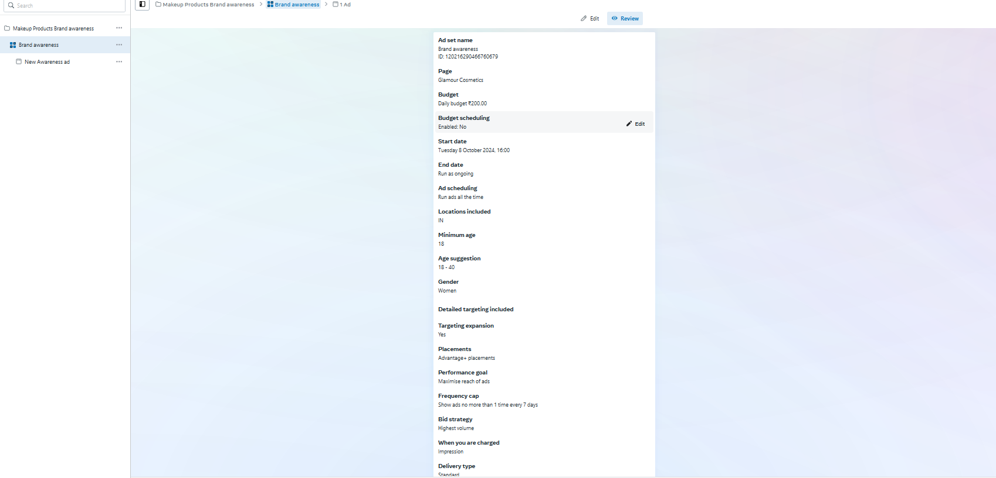

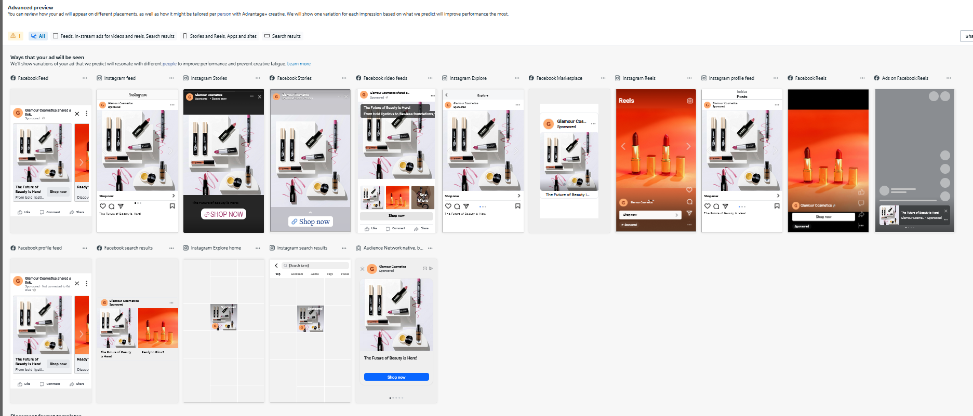

1. **Create a Facebook/ Instagram Brand Awareness Campaign**

